Good Design

Vs

Bad Design

By: Majid Al-Jahwari

A good design is very important because when something has a good design it makes it easier to use, helps fulfill its purpose and it looks good.

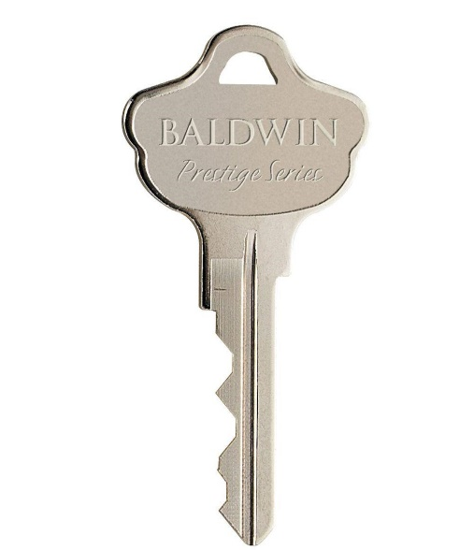In my opinion, an amazing design is the hole in a key. It helps you keep track of all your keys by putting them together in the same place. So overall, it looks good, fulfills its purpose and makes keys easier to use!

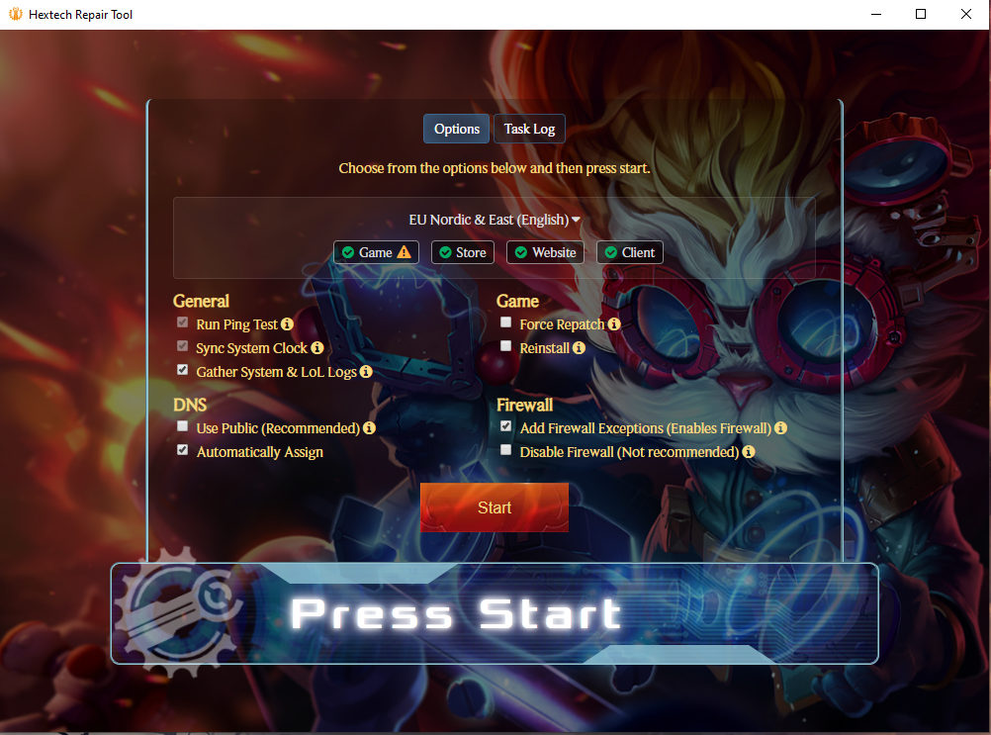

A bad design is the Hextech repair tool that riot games recommends you use whenever you have an issue with your game. It is confusing, does not look good and after using it for 3 years, I still have no clue what it does (It is supposed to repair the game, but it never does…). In my opinion, a nice way of fixing this is by coding it so that it identifies your issue and recommends ways to fix it. (If it does not fix it itself)

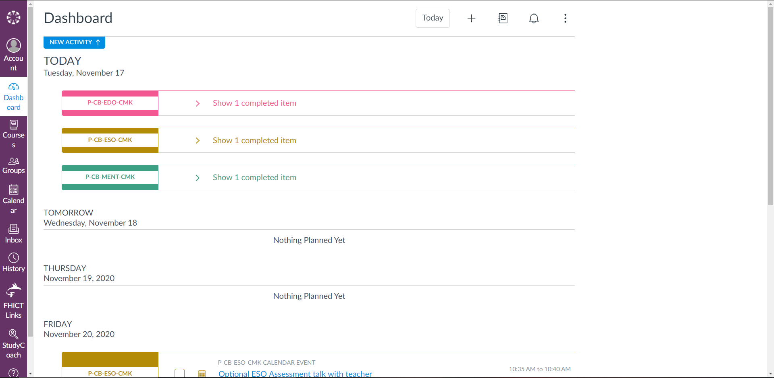

A nice example of good design is Canvas. It is easy to understand how it works, shows you everything you need to know and is a nice way to keep up with all your university assignments and announcements. I really like the option of “Calendar” because it shows me what assignments I still have to submit and when I have to submit them.

Lastly, an awful design in my opinion is the new comment section in the YouTube app. I HATE IT!!!! I am so used to scrolling down to look for the comment section and just finding more videos and a notification telling me that the comments section has been moved. I think the best way to fix this is by moving it back to the bottom of the page.

